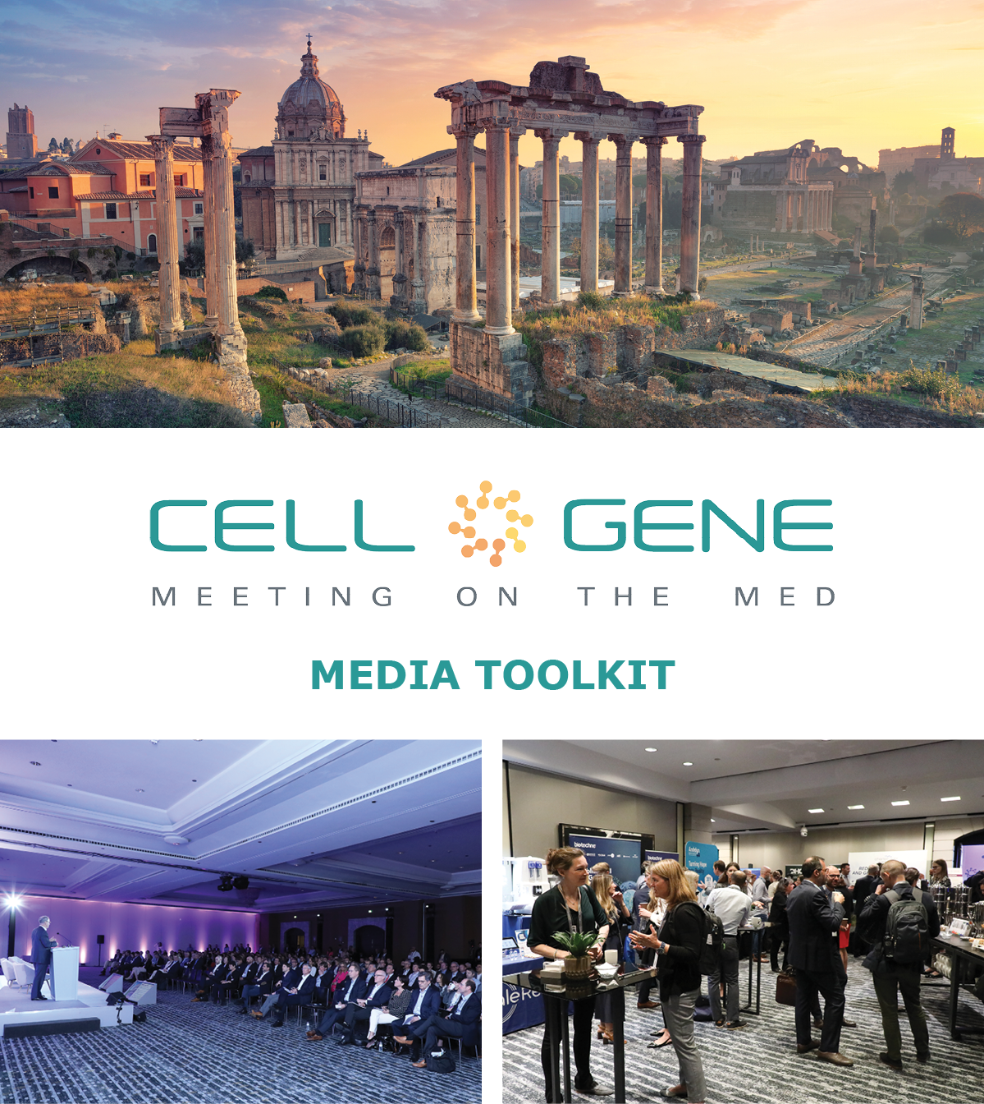

April 9 – 11, 2024 | Rome, Italy
#CGMed24
What is this Toolkit?

This toolkit is meant to help you get the most out of #CGMed24. Whether showcasing your company presentation, highlighting your speaker, or showing off your exhibit booth, sharing your experience online will drive engagement and bring visibility to your brand. Social media will also help you discover opportunities to connect virtually with new colleagues and expand your network.

How to Follow the Conversation

Follow the conference conversation with #CGMed24.

Other related hashtags are #CellandGeneTherapy, #CellTherapy, and #GeneTherapy.

If you plan on using a different hashtag, give us a tweet to let us know!

Ensure you follow the Alliance for Regenerative Medicine (ARM) to stay current on all the action. We’ll be live on social media throughout the meeting, and we have some exciting teasers we’ll be sharing in the weeks leading up to the conference.

Twitter: @alliancerm (https://twitter.com/alliancerm)
LinkedIn: Alliance for Regenerative Medicine (https://www.linkedin.com/company/alliancerm)

Share Your Experience Online

There are many ways you can engage digitally at #CGMed24!

- Like taking photographs? Post daily photos of your favorite moments.
- Are you a wordsmith? Give a readout of your favorite sessions.
- Are you a talker? Record yourself sharing your favorite moments from the day. (Don’t interrupt the speakers, please!)
  - Please note: if you plan to share any video recordings of the live sessions, please contact Adam Wolf (awolf@alliancerm.org) for prior approval.

We’ve included some suggested text for tweets and posts below to get you started – but feel free to draft your own! We’ve also provided a social banner in this media kit to include with your posts.

Activate Others

- Remember to use the hashtag #CGMed24
- Tag the Alliance for Regenerative Medicine (@alliancerm on Twitter and @Alliance for Regenerative Medicine on LinkedIn)
- Tag your colleagues to include them in the conversation!
If you have any questions about this media toolkit, please get in touch with Adam Wolf (awolf@alliancerm.org).

Suggested Posts for Twitter & LinkedIn

Date | Twitter | LinkedIn
Prior to the event | Are you attending @alliancerm’s #CGMed24? Do not miss [Speaker Name] delivering our company presentation on [Presentation date and time].  Learn more: https://meetingonthemed.com/  See you in Rome! | Are you attending the @Alliance for Regenerative Medicine’s 2024 Cell & Gene Meeting on the Med? Do not miss [Speaker Name] delivering our company presentation on [Presentation date and time].  Learn more: https://meetingonthemed.com/  See you in Rome!  #CGMed24 #cellandgenetherapy
Prior to the event | [X] days until @alliancerm’s #CGMed24! Our team looks forward to connecting with senior executives and top stakeholders to tackle the most pressing issues in cell and gene therapies.  Learn more: https://meetingonthemed.com/ | [X] days until @alliancerm’s 2024 Cell & Gene Meeting on the Med! Our team looks forward to connecting with senior executives and top stakeholders to tackle the most pressing issues in cell and gene therapies. Learn more: https://meetingonthemed.com/  See you in Rome!  #CGMed24 #cellandgenetherapy
Posts during the Conference

April 8 | Hello from Rome! We’re looking forward to Day 1 of @alliancerm’s #CGMed24 tomorrow! Check out the action-packed agenda featuring a company presentation delivered by [Speaker Name]. https://meetingonthemed.com/ | We’re excited for Day 1 of the @Alliance for Regenerative Medicine’s Cell & Gene Meeting on the Med tomorrow! Check out the action-packed agenda featuring a company presentation delivered by [Speaker Name].  https://meetingonthemed.com/
April 8 | [Company]’s team is on-site in the magnificent city of Rome for @Alliancerm’s #CGMed24. Be sure to check out our company presentation or set up a partnering meeting through the conference partnering system.  [Upload a photo or selfie!] | [Company]’s team is on-site in the magnificent city of Rome for the @Alliance for Regenerative Medicine’s 2024 Cell & Gene Meeting on the Med. Be sure to check out our company presentation or set up a partnering meeting within the conference partnering system.  #CGMed24  [Upload a photo or selfie!]
April 9 | Good morning from Rome! Day 1 of #CGMed24 is underway. We look forward to seeing everyone this week. Our team is most excited for [Provide company presentation details].  [Upload a photo or selfie!] | Good morning from Rome! Day 1 of the 2024 Cell & Gene Meeting on the Med is underway. We look forward to seeing everyone this week. Our team is most excited for [Provide company presentation details]. #cellandgenetherapy  [Upload a photo or selfie!]
April 10 | Rise and shine for Day 2 of #CGMed24.  If you haven’t already, be sure to find our team at [List time of presentation or give location of booth if you have one]  Check out today’s lineup of speakers and presentations: https://meetingonthemed.com/ | Rise and shine for Day 2 of the Cell & Gene Meeting on the Med.  If you haven’t already, be sure to find our team at [List time of presentation or give location of booth if you have one]  Check out today’s lineup of speakers and presentations: https://meetingonthemed.com/ #CGMed24
April 11 | It is already the final day of #CGMed24, and what a fantastic week it has been!  We were thrilled to hear from cell and gene therapy sector leaders this week including our very own [Give a shoutout to the speaker from your company].  [Attach 2-4 of your favorite photos from the week] | It is already the final day of #CGMed24, and what a fantastic week it has been!  We were thrilled to hear from cell and gene therapy sector leaders this week including our very own [Give a shoutout to the speaker from your company]. Here are some of our favorite moments.  [Attach 2-4 of your favorite photos from the week]

Social Media Posts:

Use the following banner with your Twitter and LinkedIn posts! Right-click on the banner and click “Save as Picture,” or download it here.

