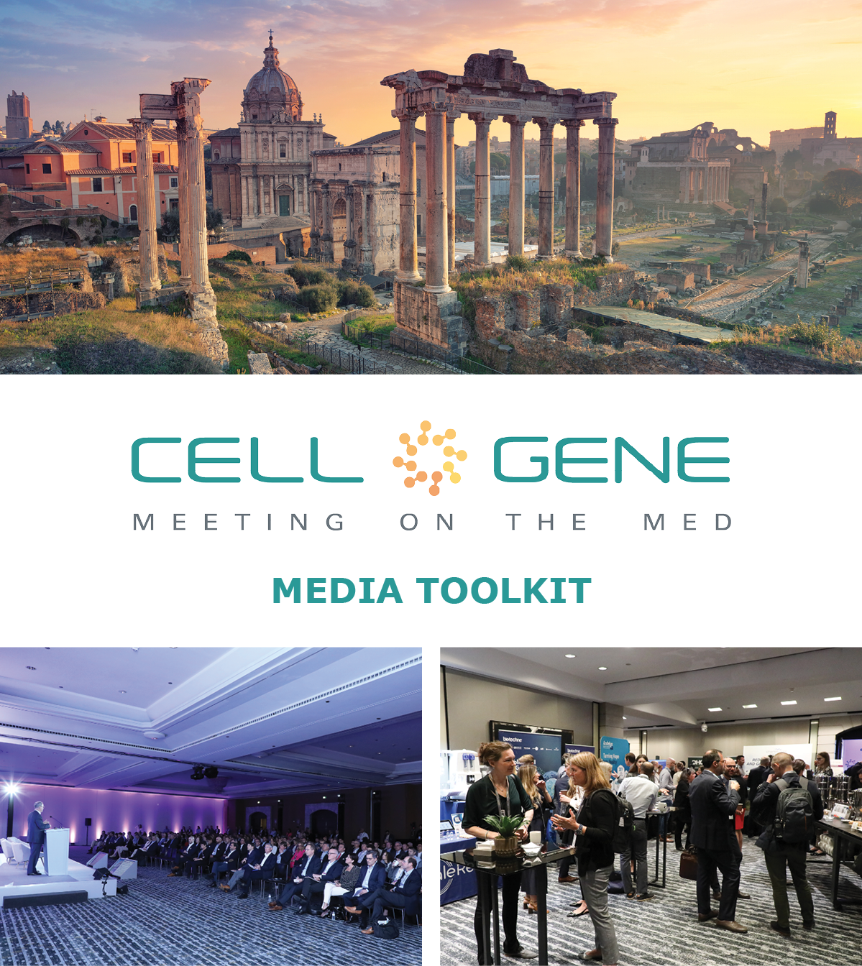

April 9 – 11, 2024 | Rome, Italy
#CGMed24
What is this Toolkit?

This toolkit is meant to help you get the most out of #CGMed24. Whether showcasing your panel, posting something you learned, or just showing off how much fun you are having, sharing your experience online will enhance your engagement with the rest of the conference. Social media will also help you discover opportunities to connect virtually with new colleagues and expand your network.

How to Follow the Conversation

Follow the conference conversation with #CGMed24.

Other related hashtags are #CellandGeneTherapy, #CellTherapy, and #GeneTherapy.

If you plan on using a different hashtag, give us a tweet to let us know!

Ensure you follow the Alliance for Regenerative Medicine (ARM) to stay current on all the action. We’ll be live on social media throughout the meeting, and we have some exciting teasers we’ll be sharing in the weeks leading up to the conference.

Twitter: @alliancerm (https://twitter.com/alliancerm)
LinkedIn: Alliance for Regenerative Medicine (https://www.linkedin.com/company/alliancerm)

Share Your Experience Online

There are many ways you can engage digitally at #CGMed24!

- Like taking photographs? Post daily photos of your favorite moments.
- Are you a wordsmith? Give a readout of your favorite sessions.
- Are you a talker? Record yourself sharing your favorite moments from the day. (Don’t interrupt the speakers, please!)
  - Please note: if you plan to share any video recordings of the live sessions, please contact Adam Wolf (awolf@alliancerm.org) for prior approval.

We’ve included some suggested text for tweets and posts below to get you started – but feel free to draft your own! We’ve also provided a social banner in this media kit to include with your posts.

Activate Others

- Remember to use the hashtag #CGMed24
- Tag the Alliance for Regenerative Medicine (@alliancerm on Twitter and @Alliance for Regenerative Medicine on LinkedIn)
- Tag your colleagues to include them in the conversation!
If you have any questions about this media toolkit, please get in touch with Adam Wolf (awolf@alliancerm.org).
Suggested Posts for Twitter & LinkedIn

Date | Twitter | LinkedIn
Prior to the event | Are you attending @alliancerm’s #CGMed24? Be sure to check out [INSERT PANEL/WORKSHOP].  Find it on the agenda: https://meetingonthemed.com/  Looking forward to connecting with sector leaders to tackle the most pressing issues facing cell and gene therapy.  See you in Rome! | Are you attending the @Alliance for Regenerative Medicine’s 2024 Cell & Gene Meeting on the Med? Be sure to check out [INSERT PANEL/WORKSHOP].  Find it on the agenda: https://meetingonthemed.com/  Looking forward to connecting with sector leaders to tackle the most pressing issues facing cell and gene therapy.  See you in Rome!  #CGMed24 #cellandgenetherapy
Prior to the event | [X] days until @alliancerm’s #CGMed24! I look forward to connecting with senior executives and top stakeholders to address the most pressing issues in cell and gene therapy.  Be sure to check out my panel [INSERT PANEL/WORKSHOP] here: https://meetingonthemed.com/ | [X] days until @alliancerm’s 2024 Cell & Gene Meeting on the Med! I look forward to connecting with senior executives and top stakeholders to address the most pressing issues in cell and gene therapy.  Be sure to check out my panel [INSERT PANEL/WORKSHOP] here: https://meetingonthemed.com/  #CGMed24 #cellandgenetherapy
Posts during the Conference

April 8 | Hello from Rome! Can’t wait for Day 1 of @alliancerm’s #CGMed24 to start tomorrow. Check out the action-packed agenda, including [List the panel or workshop you are speaking on]. https://meetingonthemed.com/  #cellandgenetherapy | Hello from Rome! Can’t wait for Day 1 of the @Alliance for Regenerative Medicine’s Cell & Gene Meeting on the Med to start tomorrow! Check out the action-packed agenda, including [List the panel or workshop you are speaking on]. https://meetingonthemed.com/  #CGMed24 #cellandgenetherapy
Day of panel | I am on-site in magnificent Rome for #CGMed24. I have the great opportunity to speak about [panel title] with my colleagues. Check out more here:  https://meetingonthemed.com/ | I am on-site in magnificent Rome for the Alliance for Regenerative Medicine’s 2024 Cell & Gene Meeting on the Med. I have the great opportunity to speak about [panel title] with my colleagues. Check out more here:  https://meetingonthemed.com/  #CGMed24 #cellandgenetherapy
April 9 | Day 1 of @alliancerm’s #CGMed24 is underway. I look forward to seeing everyone this week. Be sure to check out [Give a shoutout to your favorite panel speakers or a panel you are speaking on].  [Upload a banner photo or post a selfie!] | Day 1 of the @Alliance for Regenerative Medicine’s 2024 Cell & Gene Meeting on the Med is underway. I look forward to seeing everyone this week. Be sure to check out [Give a shoutout to your favorite panel speakers or a panel you are speaking on].  [Upload a banner photo or post a selfie!]  #CGMed24
April 10 | Rise and shine for day 2 of @alliancerm’s #CGMed24.  I am looking forward to [Give a shoutout to your favorite panel speakers or a panel you are speaking on].  Check out today’s full lineup of speakers and presentations: https://meetingonthemed.com/ | Rise and shine for day 2 of the @Alliance for Regenerative Medicine’s 2024 Cell & Gene Meeting on the Med.  I am looking forward to [Give a shoutout to your favorite panel speakers or a panel you are speaking on].  Check out today’s full lineup of speakers and presentations: https://meetingonthemed.com/
April 11 | It is already the final day of @alliancerm’s #CGMed24, and what a fantastic week it has been!  This week, I was thrilled to hear from cell and gene therapy sector leaders! Here are some of my favorite moments.  [Attach 2-4 of your favorite photos from the week] | It is already the final day of the @Alliance for Regenerative Medicine’s 2024 Cell & Gene Meeting on the Med, and what a fantastic week it has been!  This week, I was thrilled to hear from cell and gene therapy sector leaders! Here are some of my favorite moments. #CGMed24 #Cellandgenetherapy  [Attach 2-4 of your favorite photos from the week]

Social Media Posts:

Use the following banner with your Twitter and LinkedIn posts! Right-click on the banner and click “Save as Picture,” or download it here.

